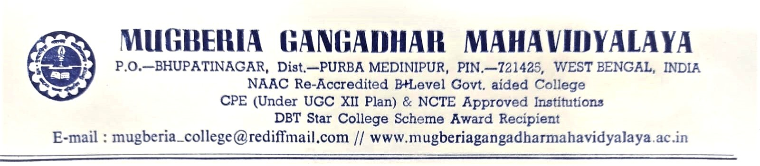

Report
On
Teacher Exchange Programme

Organized by
Department of English
Mugberia Gangadhar Mahavidyalaya

In collaboration with
Department of English
Acharya Sukumar Sen Mahavidyalaya

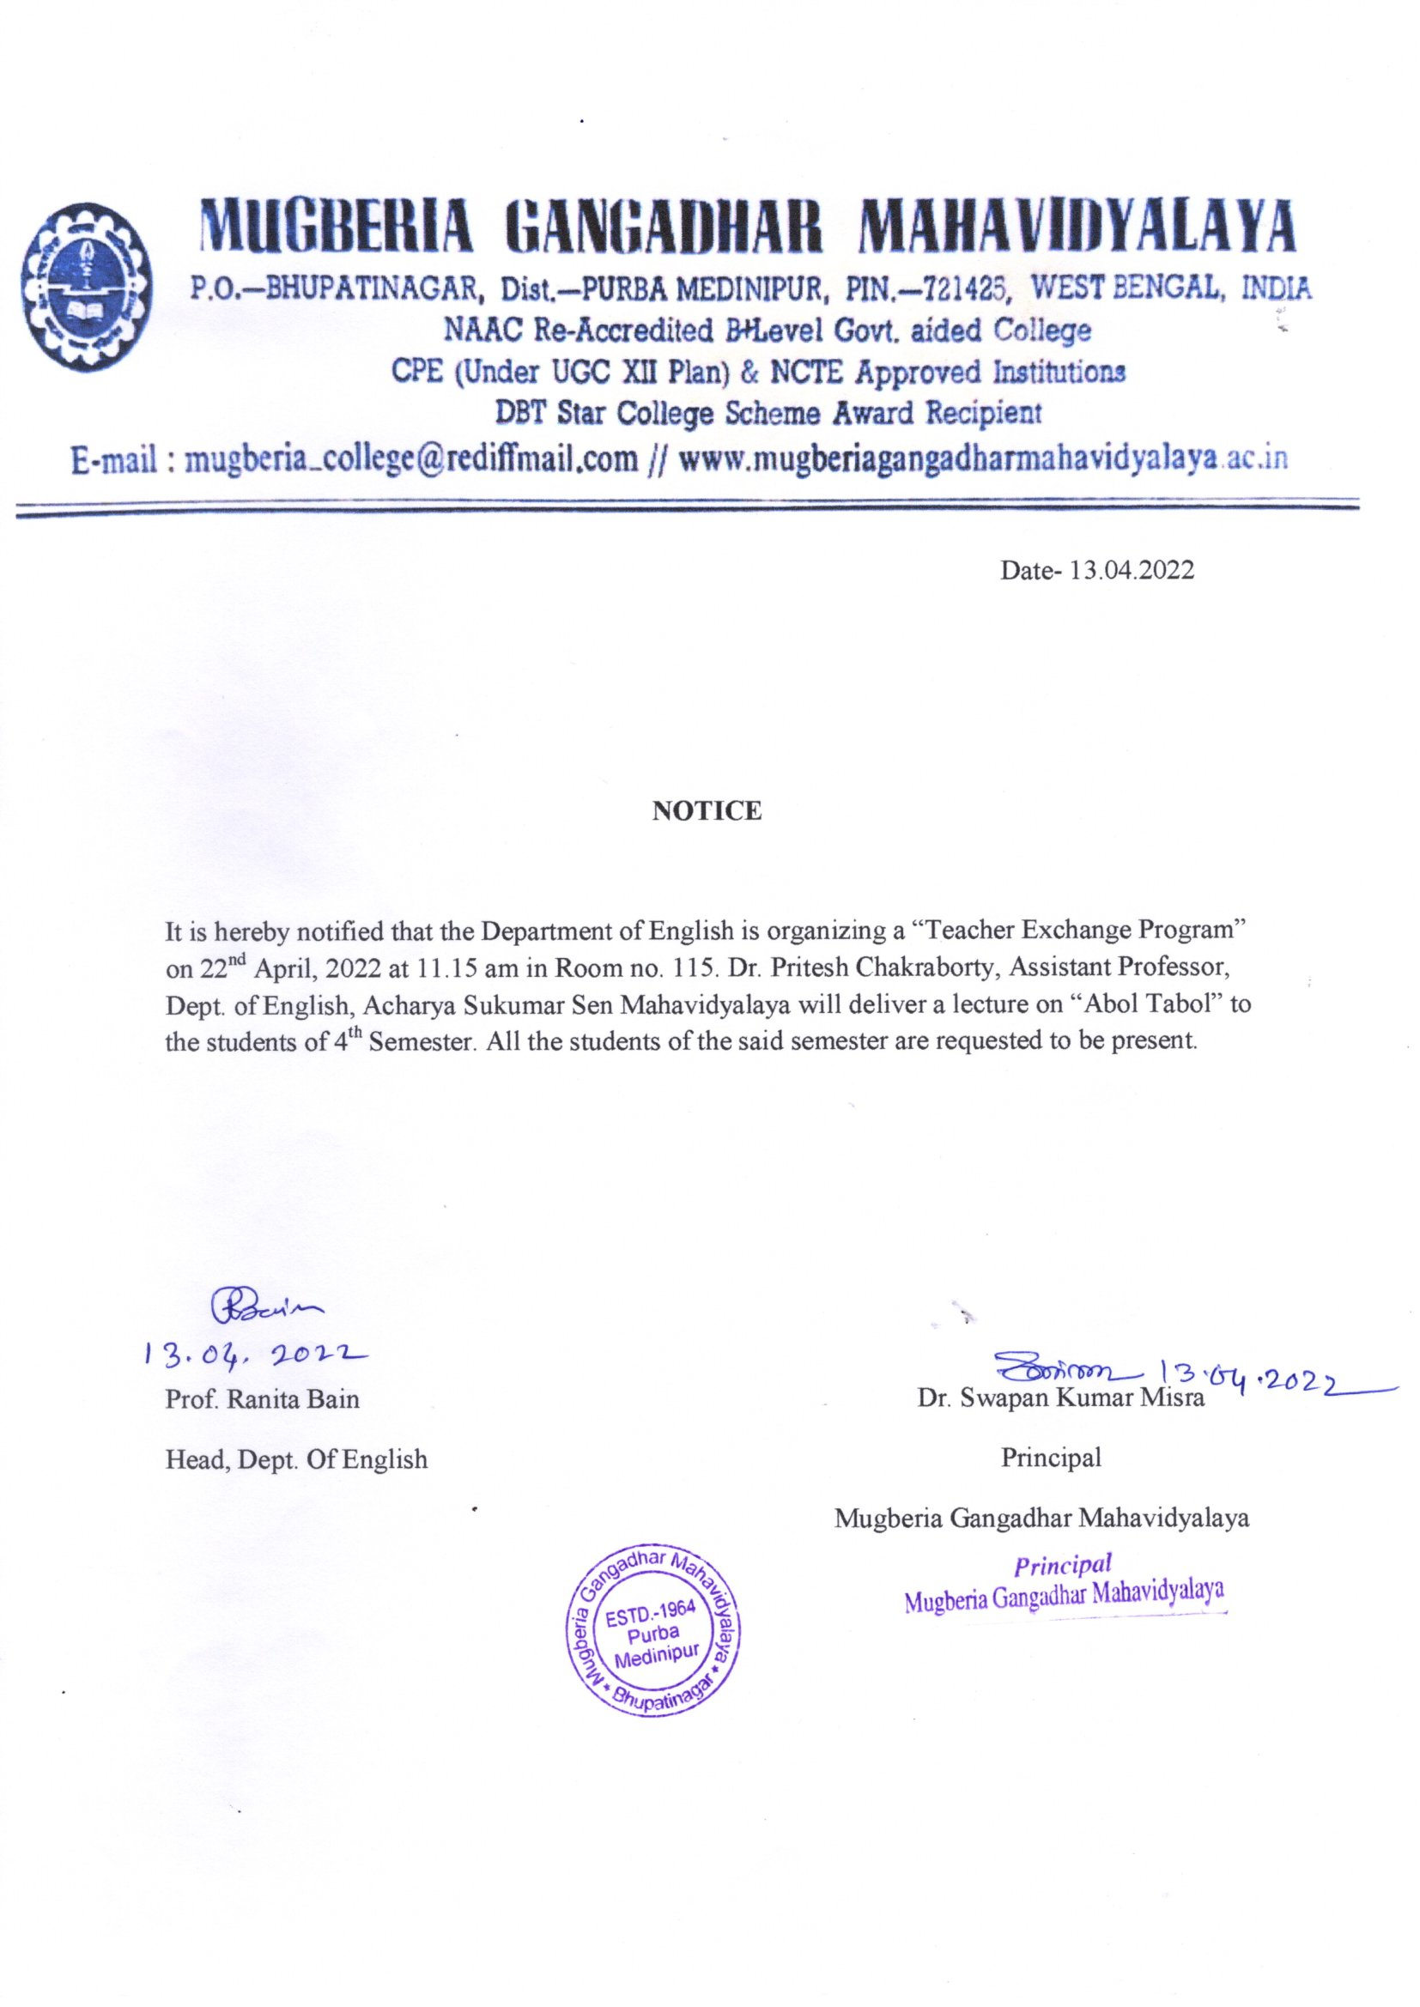

Teacher Exchange Programme
The Department of English, Mugberia Gangadhar Mahavidyalaya, organized a Teacher Exchange Program on 22 April 2022. Accordingly, Dr. Pritesh Chakraborty, Assistant Professor, Department of English, Acharya Sukumar Sen Mahavidyalaya, came to Mugberia Gangadhar Mahavidyalaya to enrich the students with his knowledge and experience on that day. Mugberia Gangadhar Mahavidyalaya already signed a MoU with Acharya Sukumar Sen Mahavidyalaya. This Teacher Exchange Program is part of it.
He shared his knowledge on AbolTabol (translated version) by Sukumar Roy with the students using a PowerPoint presentation. This particular topic comes under the syllabus of Semester IV English (Honours). So, only English (Honours) Semester IV students attended his lecture.

Students’ Participation
Almost 90 percent of the Students of Semester- IV, English (Honours), were present there. There were visible excitement and interest among the students about this event, which is very much clear from the photo that is attached with this report. They gave highly positive feedback verbally about this programme. They would love to attend more such programmes in future as well.

Outcome
This event provided a platform for students and teachers of the department of English to know the pedagogical practices of another institution. Both teachers and Students were equally excited about it.

Invitation Letter
